Tail dependence: NZDUSD and USDJPY
Method 19 / daily log returns / alpha=0.05 / Alpari D1 full available history

Study setup
Logical pair: NZDUSD , USDJPY
Broker symbols: NZDUSD_i , USDJPY_i
Snapshot: 2026-11-03_majors_alpari_D1
Timeframe: D1
Matched return window: 1999-01-05 to 2026-11-02 (UTC bar dates)
Matched return count n: 7185
Dropped unfinished last bar dated 2026-11-03 UTC after a tick-volume check against the prior complete day.
Uniforms: ranks/(n+1); alpha=0.05
Complete matched rows (Excel): NZDUSD-USDJPY_Tail_D1.xlsx
Complete matched rows (HTML table): NZDUSD-USDJPY_Tail_D1_data.html

Method carried forward
Tail dependence counts how often both legs sit in an extreme uniform tail together. Matched daily log returns of close, ln(close_t / close_t-1), become u_i = rank(x_i)/(n+1) and v_i = rank(y_i)/(n+1). At alpha=0.05, lower L_hat = (# u<=alpha and v<=alpha) / (# conditioning leg <= alpha); upper uses >= 1-alpha. Both conditioning directions are reported with numerator and denominator counts. Quotes are not inverted. L_hat(0.05) is a finite-sample frequency, not the asymptotic lambda. Same-sample Pearson r is a side check. This is not causation and not a trading signal.

Results
tail | cond | L_hat | num | denom
lower | USDJPY | 0.142061 | 51 | 359
lower | NZDUSD | 0.142061 | 51 | 359
upper | USDJPY | 0.097493 | 35 | 359
upper | NZDUSD | 0.097493 | 35 | 359
Pearson r on returns: -0.133568

Conclusion
Over 7185 matched daily rows for NZDUSD and USDJPY at alpha=0.05, lower L_hat conditioning on USDJPY is 0.1421 (51/359); conditioning on NZDUSD is 0.1421. Upper L_hat conditioning on USDJPY is 0.0975; on NZDUSD is 0.0975. Pearson r = -0.1336. These are finite-sample frequencies, not asymptotic lambda and not a trading signal.

Charts
Daily closes

Daily log returns

Uniforms with alpha lines
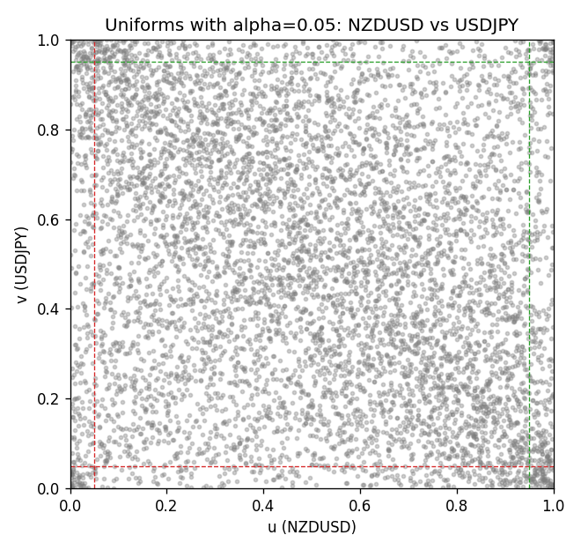

Data report
Every matched row is stored in the sibling Excel workbook named NZDUSD-USDJPY_Tail_D1.xlsx, including u and v. Embedding all rows as a Word table is impractical; this file holds column summaries and the first and last 15 matched rows.
Columns: time, NZDUSD_open, USDJPY_open, NZDUSD_high, USDJPY_high, NZDUSD_low, USDJPY_low, NZDUSD_close, USDJPY_close, NZDUSD_tick_volume, USDJPY_tick_volume, NZDUSD_spread, USDJPY_spread, NZDUSD_real_volume, USDJPY_real_volume, NZDUSD_log_return, USDJPY_log_return, u, v
Column summaries (matched calculation rows)
column | count | mean | std | min | 25% | 50% | 75% | max
NZDUSD_open | 7185 | 0.65641035 | 0.10820414 | 0.3913 | 0.59133 | 0.6684 | 0.72491 | 0.88218
USDJPY_open | 7185 | 113.80829 | 19.224285 | 75.693 | 104.39 | 110.98 | 120.695 | 163.824
NZDUSD_high | 7185 | 0.6603272 | 0.1086977 | 0.3961 | 0.59474 | 0.672 | 0.72936 | 0.88421
USDJPY_high | 7185 | 114.30556 | 19.28576 | 76.001 | 104.868 | 111.439 | 121.26 | 163.978
NZDUSD_low | 7185 | 0.65272421 | 0.10779902 | 0.3897 | 0.58806 | 0.66417 | 0.72098 | 0.87988
USDJPY_low | 7185 | 113.28523 | 19.152023 | 75.402 | 103.88 | 110.53 | 120.17 | 163.628
NZDUSD_close | 7185 | 0.65648647 | 0.10820164 | 0.3907 | 0.59157 | 0.6684 | 0.72502 | 0.8822
USDJPY_close | 7185 | 113.8211 | 19.239467 | 75.811 | 104.38 | 111.015 | 120.69 | 163.851
NZDUSD_tick_volume | 7185 | 68717.699 | 123140.61 | 16 | 5585 | 33899 | 58511 | 1127682
USDJPY_tick_volume | 7185 | 106344.18 | 179438.14 | 149 | 9948 | 53202 | 92889 | 1803508
NZDUSD_spread | 7185 | 30.280167 | 25.649381 | 0 | 9 | 17 | 40 | 80
USDJPY_spread | 7185 | 20.273626 | 17.623751 | 0 | 6 | 11 | 30 | 50
NZDUSD_real_volume | 7185 | 1.6703703e+10 | 8.4983725e+10 | 0 | 0 | 0 | 0 | 2.705649e+12
USDJPY_real_volume | 7185 | 3.4781051e+10 | 1.6093614e+11 | 0 | 0 | 0 | 0 | 3.8834203e+12
NZDUSD_log_return | 7185 | 1.284e-05 | 0.0076404 | -0.07027433 | -0.00425236 | 0.00022967 | 0.00458145 | 0.05966839
USDJPY_log_return | 7185 | 4.789e-05 | 0.00620418 | -0.03908203 | -0.00320044 | 0.00011802 | 0.00340223 | 0.05184024
u | 7185 | 0.5 | 0.28865504 | 0.00013916 | 0.25006958 | 0.5 | 0.74993042 | 0.99986084
v | 7185 | 0.5 | 0.28865504 | 0.00013916 | 0.25006958 | 0.5 | 0.74993042 | 0.99986084
First 15 matched rows (selected columns)
time | NZDUSD_log_return | USDJPY_log_return | u | v
1999-01-05 | -0.0018597736 | -0.00017868311 | 0.37343446 | 0.47105483
1999-01-06 | 0.0020455609 | 0.0075660159 | 0.61452825 | 0.91205121
1999-01-07 | 0.0062963171 | -0.012851583 | 0.82646813 | 0.023239633
1999-01-08 | -0.00055396548 | -0.0047719894 | 0.4515725 | 0.16838297
1999-01-11 | 0.010290425 | -0.016195423 | 0.93000278 | 0.01335931
1999-01-12 | -0.0053157489 | 0.032310364 | 0.20581687 | 0.99958252
1999-01-13 | -0.0099742238 | 0.0081373171 | 0.079181742 | 0.9251322
1999-01-14 | -0.00018564931 | 0 | 0.47509045 | 0.48726691
1999-01-15 | -0.00074294208 | 0.0055343401 | 0.44085722 | 0.85193432
1999-01-18 | -0.0018597736 | 8.7600193e-05 | 0.37343446 | 0.49721681
1999-01-19 | 0.0018597736 | -0.0056219403 | 0.60353465 | 0.13929864
1999-01-20 | 0.0040793678 | -0.0053879917 | 0.72550793 | 0.14639577
1999-01-21 | 0.0040627941 | 0.0084664056 | 0.72432508 | 0.92972446
1999-01-22 | -0.012051689 | 0.0060412564 | 0.052741442 | 0.86960757
1999-01-25 | -0.0035504102 | -0.0073594164 | 0.2863902 | 0.092401893
Last 15 matched rows (selected columns)
time | NZDUSD_log_return | USDJPY_log_return | u | v
2026-10-13 | 0.0047326165 | -0.0018932826 | 0.75786251 | 0.32744225
2026-10-14 | -0.0037306483 | 7.5800166e-05 | 0.27720568 | 0.49540774
2026-10-15 | 0.0047634855 | -0.0018524319 | 0.75939326 | 0.3303646
2026-10-16 | 0.0057501001 | -0.00037976126 | 0.80545505 | 0.44990259
2026-10-19 | 0.0018917133 | 0.0034946841 | 0.60631784 | 0.75521848
2026-10-20 | 0.0037199341 | -0.0022546642 | 0.70651266 | 0.30364598
2026-10-21 | 0.0030923331 | -0.00032883504 | 0.67520178 | 0.45588645
2026-10-22 | -0.0033035227 | -0.0085942669 | 0.29599221 | 0.066796549
2026-10-23 | 0.0030929853 | 0.00035080446 | 0.67534094 | 0.52170888
2026-10-26 | -0.0028993932 | 0.0041238746 | 0.31658781 | 0.79195658
2026-10-27 | -0.00026399852 | 0.0027651658 | 0.46868912 | 0.71180072
2026-10-28 | -0.0097283914 | -0.00095679538 | 0.084191483 | 0.3979961
2026-10-29 | 0.00062190714 | -0.00038043789 | 0.5257445 | 0.44976343
2026-10-30 | 0.00019537668 | -0.0010596481 | 0.49833009 | 0.39145561
2026-11-02 | -0.0025962955 | 0.0026438521 | 0.33189535 | 0.70359031

